Robert Mulligan • Eric Benjamin • Jacob Weltman • Adam Kratzer • Zachary Runk

D271 Professor David Harrison 7:00 PM



**Genicon & The Global Minimally Invasive Surgery Product Market**

**Genicon Integrating Into The Chinese Market**

# **Executive Summary:**

Genicon manufactures and sells medical instruments that assist in surgical procedures. In their respective industry, small companies usually have trouble surviving and competing with their larger competitors. Despite their apparent disadvantage--Genicon is considered a small company in their industry--they were still able to carve out a niche. Genicon possesses a unique business model: the products Genicon strategically produces have lost patent protections. Due to this strategy, Genicon grows high profits with little spending costs towards research and development. In fact, of Genicon’s 35 employees, very few are involved with research and development (D&B database and Ivey Case Study).

Despite being an American company, Genicon was forced to venture abroad to sell their products. Due to the Selling practices in the United States, startups face great adversity when entering the MIS industry. Most hospitals buy their supplies from a middleman known as a GPO (group purchasing organization). GPOs are a larger entity with much more purchasing power. By buying in bulk they are able to leverage lower costs. As a result, Genicon faces difficulties establishing its business domestically and in order to survive, they made the decision to expand abroad.

Genicon initially entered international markets in Europe. Each market Genicon enters has an associated entry cost, which on average comes out to about $70,000. The breakdown is $50,000 for up front costs, and $20,000 in distribution and contracting. These figures vary based on location, political culture, and the market of the country they enter.

Despite operating in 40 international markets, Genicon was still looking to expand. With 80% of Genicon’s sales outside of the US, Genicon is no stranger to conducting business outside the US borders and had few limitations on potential markets to enter. Genicon then considered entering the BRIC (Brazil, Russia, India, China) markets, which are considered to be the fastest growing emerging markets in the world. Due to its undeniable market potential, with regards to size and growth rate, Genicon decided to enter the Chinese, Brazilian, and Indian markets.

Although Genicon entered all of these markets, this report will focus specifically on China’s market and business standards, the surgical instrument industry as a whole and Genicon’s strategy and practices.

# **Environmental Overview/Context:**

There is much diversity in China when in comes to the languages different people speak. All Chinese today learn the national language, Mandarin, but most people grow up speaking one of the Chinese dialects. These different dialects vary both in pronunciation and vocabulary. Because the dialects are so different depending on which one a person speaks, the Chinese will switch from Mandarin to one of the dialects as a way to regulate who is a part of their conversation. Most of the time when doing business, Chinese feel more comfortable doing business with someone who speaks their own dialect and it also builds trust, so it is very important to have key people in each region who are able to speak the regional dialect.

There are two main regions of China: Eastern China and Western China. Eastern China makes up 1/3 of China’s area, but ¾’s of the population (Globesmart). The Eastern region is the fastest developing region and is known to be the reason for China’s surging economy. The individuals who live in this region of China consider themselves to be more sophisticated than those who live in the Western region. People think the reason for this is because the East has had the most contact with foreign countries, making them more liberal when it comes to foreign cultures. Western China is more of a mountainous, less populated region where civilians are typically less wealthy than those who live in the East. The people of Western China haven’t had as much contact with foreigners as those from the East, so they are usually more conservative on their outlook on other cultures. Because of the vast difference in regions, there is often times stereotyping in the workplace based on what region somebody comes from. Problems arise from the general arrogance and feeling of superiority that citizens from the East possess.

In the Chinese culture, people often care more about the group an individual belongs to rather than the individual him/herself. Unlike American culture where a person’s identity comes from what they have done or accomplished, in the Chinese culture it is all about a person’s network and relationships. Ever since China came under Communist rule, it has been emphasized that individual goals should be less important than those of the country, community, and family (Globesmart). The emphasis on social order in China, which is usually valued over individual rights, displays how the group is more important than the individual. The American concept of individualism is looked at as selfish and disruptive to social order. Someone who disagrees with the group or refuses to change their opinion to that of the group majority is considered disruptive, but someone who has the good of the group as their priority and is willing to do whatever is best for the group is looked at as someone with a lot of character and trustworthy.

In China, hierarchical relationships are what hold society together. Examples of this would be parent-child, teacher-student, and boss-subordinate. Hierarchy is believed to be the main thing that keeps social order and is reflected in all different aspects of Chinese daily life, such as greetings, language, and other behaviors in the family, community, business world, etc. The respect for hierarchy is so high that they have a virtue, called “li”, which translates to “right conduct in maintaining one’s place in the hierarchical order” (Globesmart). Basically, this virtue makes sure people show respect to others and accept the roles and responsibilities that come with their position in the hierarchy. The main determinant of hierarchy is seniority, which is typically based on age. The words of an older person in China are typically more highly valued than those of a younger person. It is because of the importance of hierarchy that the younger generations in China are so respectful to the older generations.

When doing business in China, one thing to keep in mind is that “face” is a very important part of the Chinese culture. It can be referred to as “saving face”, “building face”, or “giving face” (globesmart), all of which basically mean building up a strong reputation and preserving this reputation. Because of this part of Chinese culture, many Chinese people try to avoid any type of confrontation, whether it be in the business world or daily life. One loses face when they don’t adhere to the community norms or when they no longer trust another individual. Often times, the Chinese will send an intermediary to take care of business interactions so that there is no face lost on either side. It is very important to understand this Chinese custom because the more face a person has, the more others will trust them, which leads to better relationships and much better business.

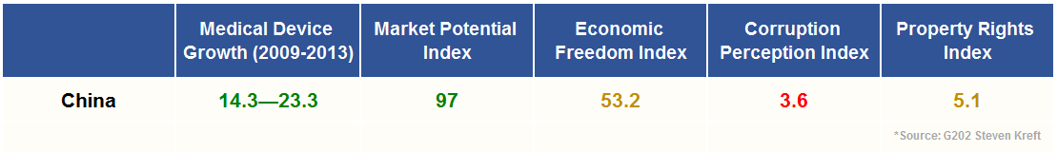

Looking at China and its political status, first we look at the type of political system that they employ. The National People’s Congress runs the country and incorporates 3,000 representatives which are elected from various provinces throughout China. The NPC is rooted in Communist ideals and has been around since 1949. Because China is a communist nation, civil liberties that are never questioned in America, are regulated in China, like Freedom of Speech and Freedom of Religion.

Before any Foreign Direct Investments are allowed, they must be approved by the Government and are subject to regulation for a period of time after their initial approval by different administrative agencies related to that specific investment. Genicon currently has to abide by high regulatory costs within China.

According to Trading Economics, China’s GDP is worth about 8,230 billion US dollars which represents about 13.27 percent of the World’s economy. And while great opportunity exists, risk is not eliminated entirely.Their involvement with any industry is very large and they have significant bargaining power with Genicon’s business. That being said, When Genicon first invested into the China market in 2010, China had very favorable arket potential with Genicon’s medical device products yet possessed little economic freedom for companies conducting business there (Heritage).

Corruption remains problem within China. In order to accomplish something in China, low level bribes sometimes must occur in some form. This type of corruption is called “petty corruption”, which is often centered around local authorities or bureaucrats that help with regulations, licences, or discretionary spending (Stephen Kreft) According to the 2013 Corruption Perceptions Index, China ranks 80th out of 177 countries with a score of 40. Corruption includes bribery, embezzlement and any type of deals that occur under-the-table.

Genicon’s business is based off of copying medical devices that their patent has expired for. That being said, it remains important to have property rights that are upheld by the country for Genicon to do business with. A major problem with companies entering into the China market is that U.S. patent laws stop at the U.S. border. Many company’s property rights have been compromised in China through counterfeited and pirated goods. Companies like Sinovel Wind Group Co have had their property rights stolen and have lost many months to the judicial system resolving this issue (Globe Staff). One thing to keep in mind is that Genicon copies medical devices that have lost their patent protection but doing business with countries without property rights remains risky.

Looking at Genicon’s industry, many factors make it difficult for startups to enter and ultimately grow and prosper. Because Genicon’s business model entails the production and distribution of surgical instruments, it again makes it difficult to for a company to enter the industry. Prospering in this industry requires significant investment in research and development. This investment is required not only upfront to enter the industry, but also additional investment to continue to prosper in the industry. Much of this industry is driven by innovation and developing new technologies. If your initial product fails and you do not have enough capital to switch to a new product, you no longer have any capability to be in the industry. Because of these factors, there are significant barriers to enter Genicon’s industry. So many large, well established companies already dominate the industry. As previously mentioned, many of these large companies sell their products to a middleman which are known as group purchasing organizations who then resell them to hospitals and other healthcare providers. Because of this structure, the well established companies have found no problems with succeeding, but the smaller companies like Genicon have faced difficulties obtaining these same GPO contracts and are thus forced to find new buyers on their own. As the below figure suggests, the majority of companies in the industry fall within the “small” classification. Subsequently, these are the companies that face more difficulty guaranteeing sales through contracts with GPOs. Part of the reason Genicon actually made the move internationally was because of their inability to capture any market share within the US borders. These factors are both significant barriers of entry in this industry as well as proof that there is significant threat of substitution at least for the smaller companies.

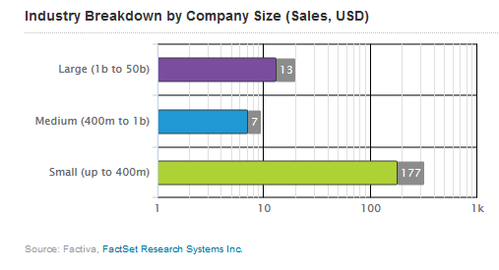

Going off that last point, this leads to an important point on the relative bargaining power of buyers. Unless a company is classified as the minority in the industry(medium or large sized), buyers are easily able simply switch to a competitor. This again would not be the case if the company falls in the minority status as they’re basically guaranteed to sell their product for at least a fixed amount of time as they are likely to be contracted to a GPO. The majority of companies in the industry (small) thus have no guaranteed channel of distribution which contributes to the relative bargaining power of the buyers. If unhappy in any way, a buyer can more than likely switch to a competitor because they do not have to respect a contract. Obviously, this has a correlation to the last force about threat of substitution but also applies to the relative bargaining power of buyers in the industry.

The distribution channel also provides information about the bargaining power of supplies. For the very same reasons, companies in this industry are more than likely to face difficulties because of their low bargaining power. As we mentioned in the previous paragraph, buyers of the instruments can switch to substitutes unless under contracts with GPOs. This leaves little strength in the distribution channel for suppliers. Additionally, because many firms are classified as small there is significant competition to win out in sales. A high percentage of companies are at the mercy of their buyers; there is virtually little to no advantages the suppliers possess in the business relationship. The fierce competition in this industry is the final force in the Porter’s Five Forces. Because there are many companies at the bottom of this hierarchal industry, competition to win business is high. As previously mentioned, research and development drives this industry in which success is determined by innovation. The degree of innovation a company can generate also contributes to its differentiation. Ultimately, differentiation is what separates companies in the industry and creates competitive advantages. In summary, the industry requires innovation from investment in research and development in order to stand out from the competition which leads to a competitive playing field in the industry.

# **Company/Industry Context:**

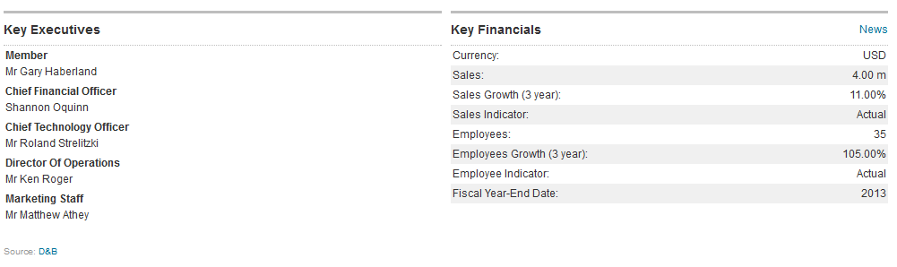

Genicon is currently recognized as an up and coming leader in the surgical instrument industry, specifically focusing on the design, production, and distribution of patented instruments for laparoscopic surgery. The company was founded in 1998 in Orlando, Florida and is a privately held company. They began as an Original Equipment Manufacturer and produced products for larger medical device firms with their own brand labeling.

Laparoscopic surgery represents one of the largest medical segments with about 7.5 million surgeries performed annually worldwide. Driven by a many recently discovered benefits, laparoscopy has evolved into a surgical standard with a sizeable number of open surgeries shifting steadily to this surgical procedure over the past decade. The United States represents the single largest market, while Asia-Pacific and Latin America represent rapidly growing markets worldwide. Asia Pacific is forecast to grow at the fastest CAGR of 7.3% over the analysis period.

|  |  |
| --- | --- |
| **Strengths**   * Growing demand for minimally invasive procedures * Increased availability of highly trained surgeons * Growing popularity of single-incision laparoscopic surgery * Represents one of the largest medical segments with about 7.5 million surgeries performed annually worldwide * Low threat of new entrants to industry | **Weaknesses**   * Less innovative than other companies in industry (less R&D investment + staff size) * Small staff in a global setting requires * Surgeons must be skilled in using the MIS instruments * The growth rate for this industry is forecasted to decline year-over-year * Issues involving the re-use of disposable instruments has put downward pressure on sales in some international markets |
| **Opportunities**   * Large numbers of open surgeries shifting to this procedure over the past couple years * Many healthcare systems and hospitals worldwide are adopting these procedures * The use of laparoscopy for other uses are currently being researched * Global growth allows lucrative market openings | **Threats**   * Countries that don’t respect intellectual property, local companies use trade secrets of Genicon and take away competitive advantage * Large suppliers of products in domestic market move abroad and establish similar contracts with GPOs |

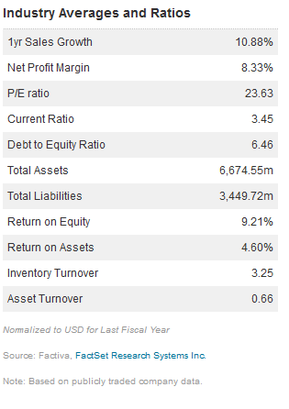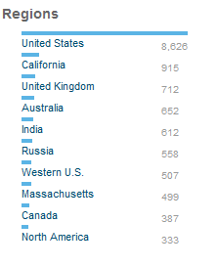 Source: Factiva

Genicon’s industry is expected to reach $ 35.5 Billion in 2016. Explosive growth in the industry makes the market lucrative and competitive. Genicon works to leverage it’s green company status to gain this new growth market share.

*Green Initiative(i)*

“GENICON is currently in the process of engineering a new Palm Bladeless line of Visual Tip Trocars that will require approximately 70% less plastic to produce than our current pistol grip version.”

Genicon builds their strategy based upon certain values and company culture ideals. These values provide a foundation for the company to grow from and act as a framework for decision.

GENICON Values(i)

Through our employees, GENICON embraces key values of:

* **Customer focus**: Achieve our mission, our primary focus is to make our Customers successful in executing their work by serving their need.
* **Teamwork**: Working together, we create a force multiplier for intelligent solutions and Customer satisfaction.
* **Integrity**: Integrity and honest behavior is the cornerstone of the trust we create with all stakeholders. At all times, GENICON shall abide by legal and regulatory requirements.
* **Innovation**: The best source of growth is the creativity of our people. All employees contribute to finding the right answers, and all employees are accountable for continually improving.
* **Leadership**: Take personal responsibility for making our company successful. Each of us has multiple opportunities daily to please a Customer, help a colleague, and do our jobs better

(i) - From company website

# **Conclusion, Recommendation & Summary:**

When doing business in a country, it is important for GENICON to be aware of cultural, political, economic, and labor factors. In this particular case, we consider these factors with how they relate to conducting business in China.

Although the United States has some similarities with China culturally, there are many differences that they should be aware of if they want to succeed and remain in China going forward. A few of these are as follows: language (different dialects and there is more trust when doing business if managers can speak regional dialect) and hierarchy (hierarchical relationships hold Chinese society together and disrespecting one of your superiors loses trust). Building relationships and trust is also very important when doing business in China because most Chinese will not do business with someone they don’t trust. The most important factor is that if managers work in China without respecting their culture and being knowledgeable of the different aspects, it will be hard to get things accomplished.

The National People’s Congress is the national legislature of China and is rooted with Communist ideals. The NPC has been around since 1949, and because of the Communist ideals, civil liberties such as freedom of speech and freedom of religion are regulated. The most prominent political issue in China is the corruption. They scored a 40 on the 2013 Corruption Index, which scores countries from 0 (highly corrupt) to 100 (very clean).

The government must approve all foreign direct investments before they are allowed in the country, which usually leads to high regulatory costs because they then have to be regulated by different administrative agencies after government approval. Also with regards to the government, we believe it’s imperative that Genicon maintain a solid relationship with the government given the political structure. This can be done through meetings with leaders, lobbying, and many other actions. Because of this governmental structure in China, we believe Genicon must do certain things to continue to be successful in this particular market. Maintaining strong relationships with the government leaders could help out in the long run, and may actually serve as a lobbying effort leading to benefits for Genicon. Not doing this could lead to more monitoring and regulation. Going off this point, we even recommend that Genicon go as far as participate in some forms of corruption (petty). The US government allows petty corruption as long as a company can prove it’s necessary for business functions.

Now moving on to the industry, this is a very tough industry for companies to get into because of the significant investments needed for research and development. Also, additional capital is needed upon entering the industry because it is driven by innovation and developing new technologies, so you need a lot of money to continue doing these things.

Buyers of the instruments in this industry can switch to substitutes unless under contracts with GPOs. This leaves little strength in the distribution channel for suppliers. There are many companies at the bottom of this hierarchal industry, which leads to very high competition to win business. Success in this industry is determined by innovation and the degree of a company’s innovation contributes to its differentiation from other companies.

